# PRACTICAL – 6

**Aim:** **Write a C program in LINUX to implement Process scheduling algorithms and compare.**

**A**: **First Come First Serve (FCFS) Scheduling**

**PROGRAM:**

#include<stdio.h>

void findWaitingTime(int processes[], int n,int bt[],int wt[])

{

wt[0] = 0;

for (int i = 1; i < n ; i++ )

wt[i] = bt[i-1] + wt[i-1] ;

}

void findTurnAroundTime( int processes[], int n,int bt[], int wt[], int tat[])

{

for (int i = 0; i < n ; i++)

tat[i] = bt[i] + wt[i];

}

void findavgTime( int processes[], int n, int bt[])

{

int wt[n], tat[n], total_wt = 0, total_tat = 0;

findWaitingTime(processes, n, bt, wt);

findTurnAroundTime(processes, n, bt, wt, tat);

printf("Processes Burst time Waiting time Turn around time\n");

for (int i=0; i<n; i++)

{

total_wt = total_wt + wt[i];

total_tat = total_tat + tat[i];

printf(" %d ",(i+1));

printf(" %d ", bt[i] );

printf(" %d",wt[i] );

printf(" %d\n",tat[i] );

}

int s=(float)total_wt / (float)n;

int t=(float)total_tat / (float)n;

printf("Average waiting time = %d",s);

printf("\n");

printf("Average turn around time = %d ",t);

}

int main()

{

int processes[] = { 1, 2, 3};

int n = sizeof processes / sizeof processes[0];

int burst_time[] = {10, 5, 8};

findavgTime(processes, n, burst_time);

return 0;

}

**OUTPUT:**

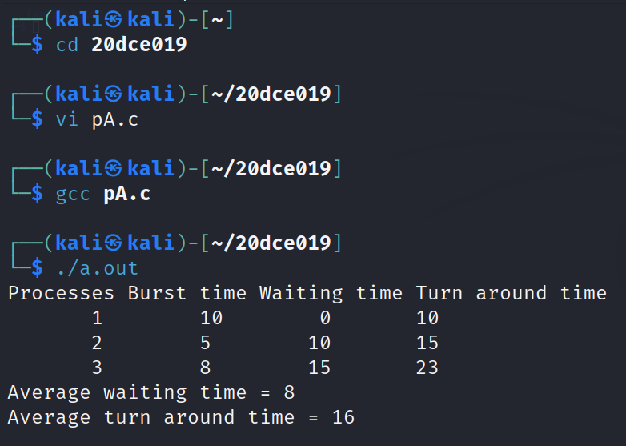

**B**: **Shortest-Job-First (SJF) Scheduling**

**PROGRAM:**

#include<stdio.h>

int main()

{

int bt[20],p[20],wt[20],tat[20],i,j,n,total=0,pos,temp;

float avg_wt,avg_tat;

printf("Enter number of process:");

scanf("%d",&n);

printf("nEnter Burst Time:n");

for(i=0;i<n;i++)

{

printf("p%d:",i+1);

scanf("%d",&bt[i]); p[i]=i+1;

}

for(i=0;i<n;i++)

{

pos=i;

for(j=i+1;j<n;j++)

{

if(bt[j]<bt[pos])

pos=j;

}

temp=bt[i];

bt[i]=bt[pos];

bt[pos]=temp;

temp=p[i];

p[i]=p[pos];

p[pos]=temp;

}

wt[0]=0;

for(i=1;i<n;i++)

{

wt[i]=0;

for(j=0;j<i;j++)

wt[i]+=bt[j];

total+=wt[i];

}

avg_wt=(float)total/n;

total=0;

printf("\nProcesst Burst Time tWaiting TimetTurnaround Time");

for(i=0;i<n;i++)

{

tat[i]=bt[i]+wt[i];

total+=tat[i];

printf("\np%d\t\t %d\t\t %d\t\t\t%d",p[i],bt[i],wt[i],tat[i]);

}

avg_tat=(float)total/n;

printf("\n\nAverage Waiting Time=%f",avg_wt);

printf("\nAverage Turnaround Time=%f \n",avg_tat);

}

**OUTPUT:**

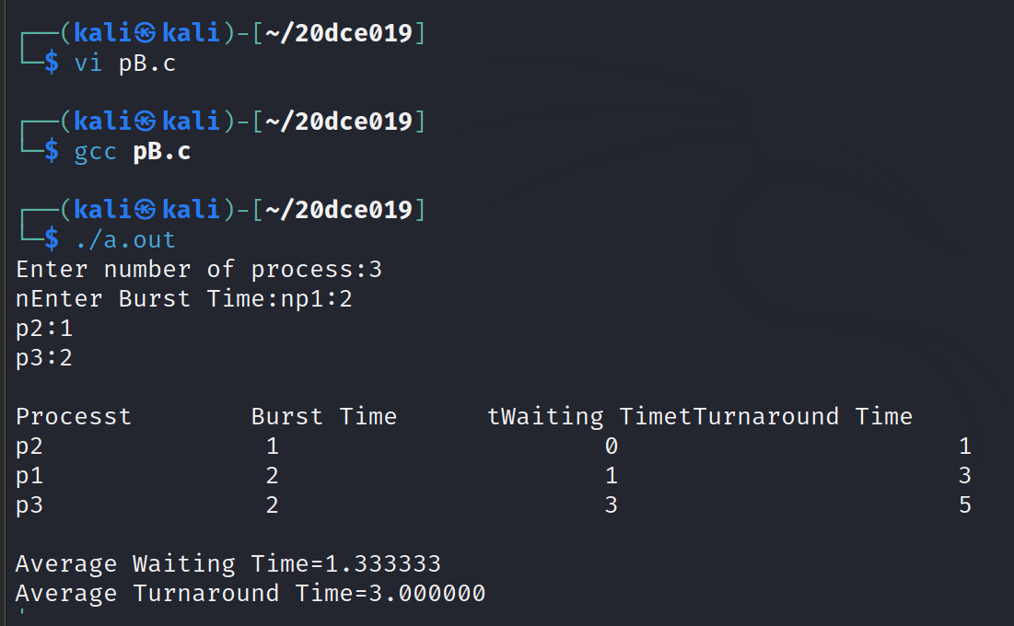

**C**: **Priority Scheduling (Non-preemption) after completion extend on Preemption.**

**PROGRAM:**

#include<stdio.h>

int main()

{

int bt[20],p[20],wt[20],tat[20],pr[20],i,j,n,total=0,pos,temp,avg_wt,avg_tat;

printf("Enter Total Number of Process:");

scanf("%d",&n);

printf("\nEnter Burst Time and Priority\n");

for(i=0;i<n;i++)

{

printf("\nP[%d]\n",i+1);

printf("Burst Time:");

scanf("%d",&bt[i]);

printf("Priority:");

scanf("%d",&pr[i]); p[i]=i+1; }

for(i=0;i<n;i++)

{

pos=i;

for(j=i+1;j<n;j++)

{

if(pr[j]<pr[pos]) pos=j;

}

temp=pr[i];

pr[i]=pr[pos];

pr[pos]=temp;

temp=bt[i];

bt[i]=bt[pos];

bt[pos]=temp;

temp=p[i];

p[i]=p[pos];

p[pos]=temp;

}

wt[0]=0;

for(i=1;i<n;i++)

{

wt[i]=0;

for(j=0;j<i;j++)

wt[i]+=bt[j];

total+=wt[i];

}

avg_wt=total/n;

total=0;

printf("\nProcess\t Burst Time \tWaiting Time\tTurnaround Time");

for(i=0;i<n;i++)

{

tat[i]=bt[i]+wt[i];

total+=tat[i];

printf("\nP[%d]\t\t %d\t\t %d\t\t\t%d",p[i],bt[i],wt[i],tat[i]);

}

avg_tat=total/n;

printf("\n\nAverage Waiting Time=%d",avg_wt);

printf("\nAverage Turnaround Time=%d\n",avg_tat);

return 0;

}

**OUTPUT:**

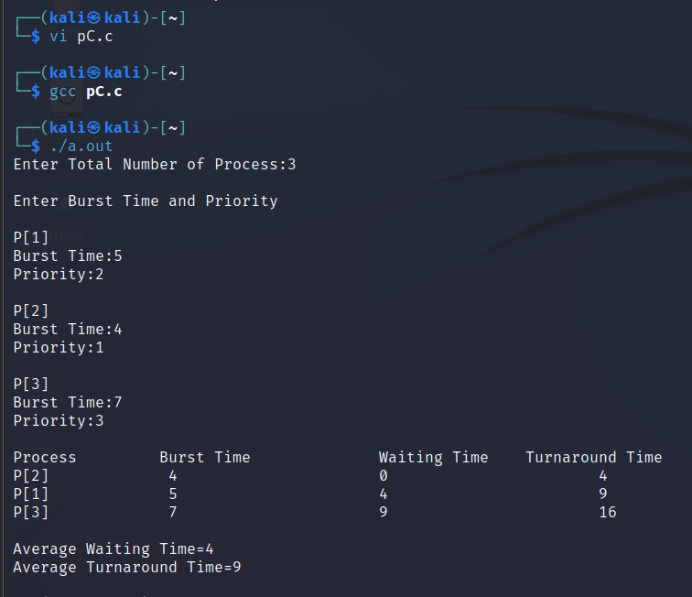

**D**: **Round Robin(RR) Scheduling**

**PROGRAM:**

#include<stdio.h>

int main()

{

int i, limit, total = 0, x, counter = 0, time_quantum;

int wait_time = 0, turnaround_time = 0, arrival_time[10], burst_time[10], temp[10];

float average_wait_time, average_turnaround_time;

printf("Enter Total Number of Processes:");

scanf("%d", &limit);

x = limit;

for(i = 0; i < limit; i++)

{

printf("Enter Details of Process[%d]", i + 1);

printf("Arrival Time:");

scanf("%d", &arrival_time[i]);

printf("Burst Time:");

scanf("%d", &burst_time[i]);

temp[i] = burst_time[i];

}

printf("Enter Time Quantum:");

scanf("%d", &time_quantum);

printf("Process ID Burst Time Turnaround Time Waiting Time");

for(total = 0, i = 0; x != 0;)

{

if(temp[i] <= time_quantum && temp[i] > 0)

{

total = total + temp[i];

temp[i] = 0;

counter = 1;

}

else if(temp[i] > 0)

{

temp[i] = temp[i] - time_quantum;

total = total + time_quantum;

}

if(temp[i] == 0 && counter == 1)

{

x--;

printf("\nProcess[%d] %d %d %d", i + 1, burst_time[i], total - arrival_time[i], total - arrival_time[i] - burst_time[i]);

wait_time = wait_time + total - arrival_time[i] - burst_time[i];

turnaround_time = turnaround_time + total - arrival_time[i];

counter = 0;

}

if(i == limit - 1)

{

i = 0;

}

else if(arrival_time[i + 1] <= total)

{

i++;

}

else

{

i = 0;

}

}

average_wait_time = wait_time * 1.0 / limit;

average_turnaround_time = turnaround_time * 1.0 / limit;

printf("\nAverage Waiting Time:%f", average_wait_time);

printf("\nAvg Turnaround Time:%f", average_turnaround_time);

return 0;

}

**OUTPUT:**

